CO 2 Assessment Tool 1-Part 3
Name: - G. Akshya Reg No: -192425132
Course Code: -MLA0305 Slot: -B

Fig 1: -Way Ground Test 1

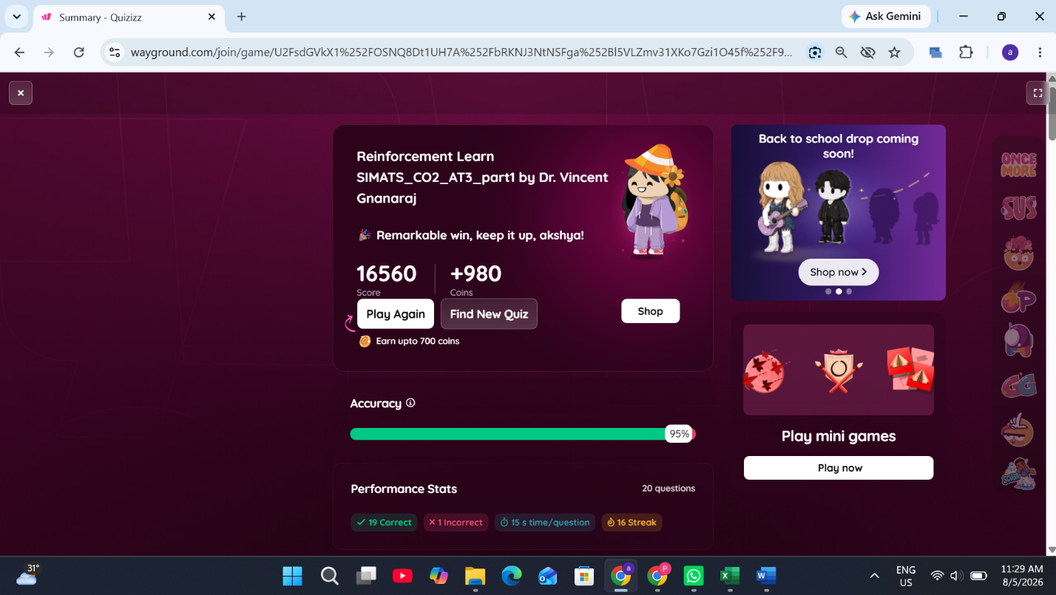
Fig 2: -Way Ground Test 2

